Full Name: ____________________________________________________________________________
Address: ________________________________ City: ____________ State: __________ Zip: _________
Phone (Home): ____________________ (Work):____________________ (Cell): ____________________
Date of Birth:________________ Age: _______ Employer: _____________________________________ Occupation:_______________________________ Emergency Contact: ____________________________ Phone: ____________Relationship: ____________ Referred by: _________________________________ Marital Status: _______ Email: ___________________________________________________________
How did you hear about us? __ Our website __ Internet __ Newspaper Ad __ Yellow Pages __ Family/Friend? (Who: __________________________ Other __________________________ Is this your first professional massage? ______ If no, how frequently do you get a massage? ____________ What do you hope to accomplish from today's message? ________________________________________________
Are you aware of any tension holding spots in your body? ____ If yes, location(s) ____________________
______________________________________________________________________________________
Describe any surgeries, hospitalizations, accidents or injuries you have had in the last 10 years: _________
______________________________________________________________________________________
What kind of care did you receive for your accidents or injuries? _________________________________
Do you feel that you have recovered from these events? _______ Please explain: ____________________
Do you have any chronic, ongoing pain that you deal with on a regular basis? _____ Please explain: _____
______________________________________________________________________________________
Describe what activities cause this pain and or makes it worse: ___________________________________
Are you receiving any other type of medical treatment? _____ Please explain: _______________________
Please list any medication (vitamins, herbs or pharmaceutical) taken now or at regular intervals (include explanation of what medication is used to treat): _______________________________________________
______________________________________________________________________________________Are you currently under the care of a physician?_______ Whom? _______________________________
Please list reason(s): _____________________________________________________________________
Are there any other health concerns you wish to discuss today? Yes / No If yes, please describe: ______________________________________________________________________________________
Are you currently experiencing any of the following conditions? ____Flu or Cold ____Inflammation ____Fever ____Infection ____Contagious Disease ___ Other _______________________________
Please check any of the following conditions below that currently affect you or that you have experienced in the last 10 years. Circle if condition checked is being experienced now.
Musculoskeletal |  | Circulatory |  | Nervous System
___ | Arm/ Shoulder Pain | ___ | Anemia | ___ | ALS
___ | Bursitis | ___ | Blood Clots / Phlebitis | ___ | Bell’s Palsy
___ | Carpal Tunnel Syndrome | ___ | Diabetes | ___ | Multiple Sclerosis
___ | Cysts | ___ | Heart condition | ___ | Neuritis
___ | Fibromyalgia | ___ | Hemophilia | ___ | Numbness/Tingling/Twitch
___ | Gout | ___ | Hypertension | ___ | Parkinson’s Disease
___ | Headache | ___ | Low blood pressure | ___ | Seizure Disorders
___ | Hip Pain | ___ | Raynaud’s Disease | ___ | Spinal Cord Injury
___ | Leg Pain | ___ | Varicose Veins | ___ | Stroke
___ | Low Back Pain | ___ | Other | ___ | Trigeminal Neuralgia
___ | Mid Back Pain | Digestive |  | ___ | Other
___ | Osteoporosis | ___ | Colitis | Other
___ | Osteoarthritis/Rheumatoid | ___ | Crohn’s Disease | ___ | Anxiety/Panic Attacks
___ | Plantar Fasciitis | ___ | Diarrhea | ___ | Bladder Infection
___ | Postural Deviations | ___ | Gallstones | ___ | Cancer (Stage: 1, 2, 3, 4)
___ | Sciatica | ___ | Gas / Bloating | ___ | Chronic Fatigue
___ | Scleroderma | ___ | Hepatitis | ___ | Edema
___ | Spasms / Cramps | ___ | Indigestion / GERD | ___ | Grief Process
___ | Sprains / Strains | ___ | Irritable Bowel Syndrome | ___ | HIV / AIDS
___ | Tendonitis | ___ | Ulcers | ___ | Insomnia
___ | Thoracic Outlet Syndrome | ___ | Other | ___ | Kidney Disease
___ | TMJ Dysfunction |  |  | ___ | Lupus
___ | Torticollis | Skin |  | ___ | Trouble Breathing
___ | Whiplash Syndrome | ___ | Athletes Foot | ___
___ | Other | ___ | Dermatitis/Eczema | ___ | Postoperative Situation
Respiratory |  | ___ | Fungal Infections - Acne | ___ | Sleep Apnea
___ | Asthma | ___ | Impetigo | ___ | PMS
___ | Dizziness | ___ | Psoriasis | ___ | Substance Abuse
___ | Oxygen (liters: _____) | ___ | Open Wound or Sore | ___ | Other
___ | Pneumonia | ___ | Rashes | ___ | ______________________
___ | Sinusitis | ___ | Warts / Moles | ___ | ______________________

Please CIRCLE the area or areas where you experience pain or discomfort on the drawing below:
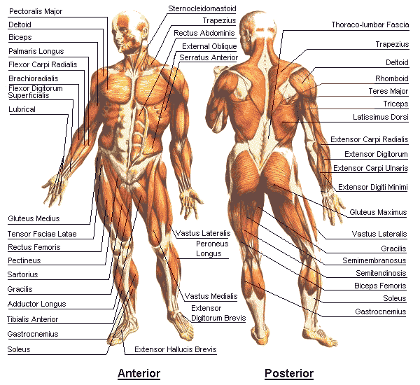
The above information is accurate and true to the best of my knowledge. I understand that massage therapists do not diagnose disease, prescribe medications, or manipulate bones. I further understand that massage therapy is not a substitute for medical attention or examination. I take responsibility for alerting my practitioner to any physical, mental, or emotional changes that occur with my health. I also understand that cancelled or missed appointments without 24 hours notice (medical emergencies excluded) will be charged in full for the price of the missed session. If I have requested a full body massage I acknowledge that everything except front lower genital region may be massaged as discussed with my therapist.
Signature: ______________________________________ Date:_________________________________

